**EcoScan**

**Product Capstone**

| **Team ID** | **:** | **C23-PR526** |
| --- | --- | --- |
| **Selected Themes/Case** | **:** | Sustainable Living |
| **Mentor Name** | **:** | **Yusuf Firdaus Arifi,** 29 May 2023 at 8:45 – 9:45 pm  **Ari Kusyannti,** 09 June at 10.30 - 11.00 am |
| **Member Name** | **:** |  |

1. M350DSY1435 – Hajarani Syadzwana – Universitas Sumatera Utara - Machine Learning - [Active]
2. M350DSX1794 – Muhammad Iqbal Aldeena – Universitas Sumatera Utara - Machine Learning - [Active]
3. M125DKY4655 – Azilla Auri Pramesti – UIN Syarif Hidayatullah Jakarta - Machine Learning - [Active]
4. C350DSX1608 – T.M. Rezha Taufiqurrahman, Mx – Universitas Sumatera Utara - Cloud Computing - [Active]
5. C058DKX4155 – Afdan Syukron – Politeknik Negeri Banyuwangi - Cloud Computing - [Active]
6. A034DKX4179 – Putra Cendikia Subekti – Institut Teknologi Kalimantan - Mobile Development - [Active]

**Backgrounder:**

1. Machine Learning: Build a machine learning model with DenseNet 121 transfer learning then add GlobalAveragePooling2D and Dense layers, collect data by downloading all images from chrome then selecting the appropriate image, resize and split image with a comparison of training and validation 70 : 30. Preprocessing with image augmentation. Then save the model with the .h5 extension and evaluate the confidence level of each class with the available test images and achieve 90% - 100% of confidence
2. Mobile Development involves the process of creating an Android application using the programming language Kotlin. In this development, we integrate an API that incorporates Machine Learning capabilities using Retrofit2. We also focus on managing error probabilities efficiently. To ensure a well-organized structure, we implement a clean architecture approach. For handling dependencies, we utilize DaggerHilt, which facilitates dependency injection. Additionally, we employ the Navigation Component and Fragment for user interface design, utilizing safeArgs for smooth navigation between screens.
3. Cloud Computing: Implement the Flask API framework to handle requests by the user as well as setting up databases, VM Instances, and Cloud SQL to handle all the appropriate requirements for the projects. Also handing out API for the Mobile Development to be consumed.

Our application is able to provide knowledge about energy used in everyday life. has integrated machine learning, cloud computing and mobile development well and has succeeded in making an apk that can run according to the purpose able to take pictures from the camera or internal storage and detect the category of images and then display the details. Displays history and provides convenience for custom selections and displays the energy usage of the selected item from the drop down selection, displays a page about the team's vision and mission in making applications and information from the team.

**Project Status :**

1. 100%

**Screenshot of the Application:**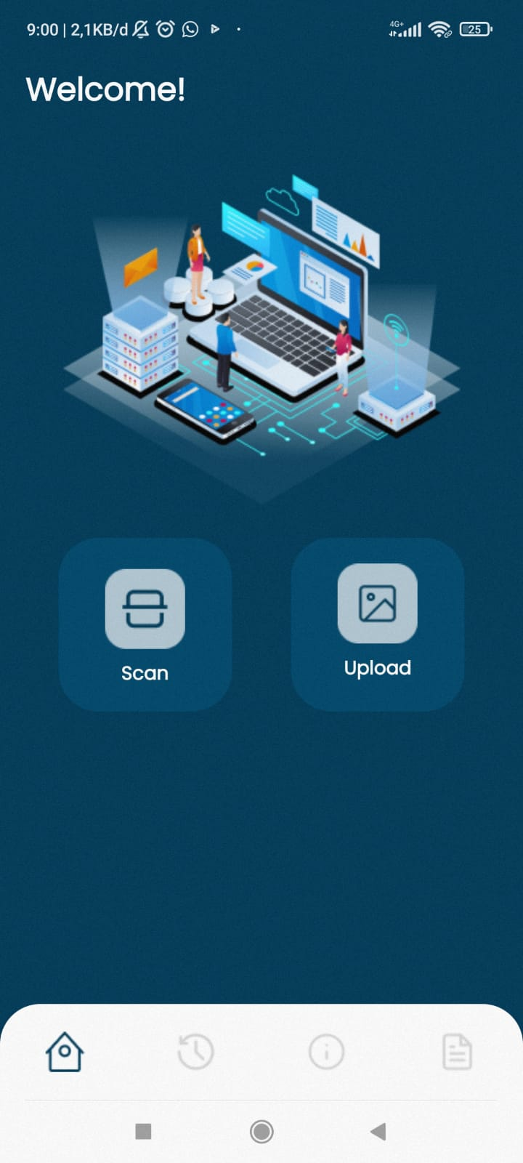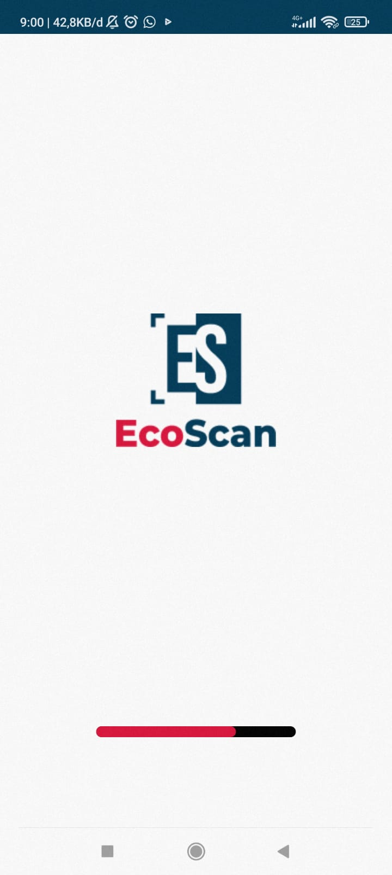

Splash Screen Home Screen

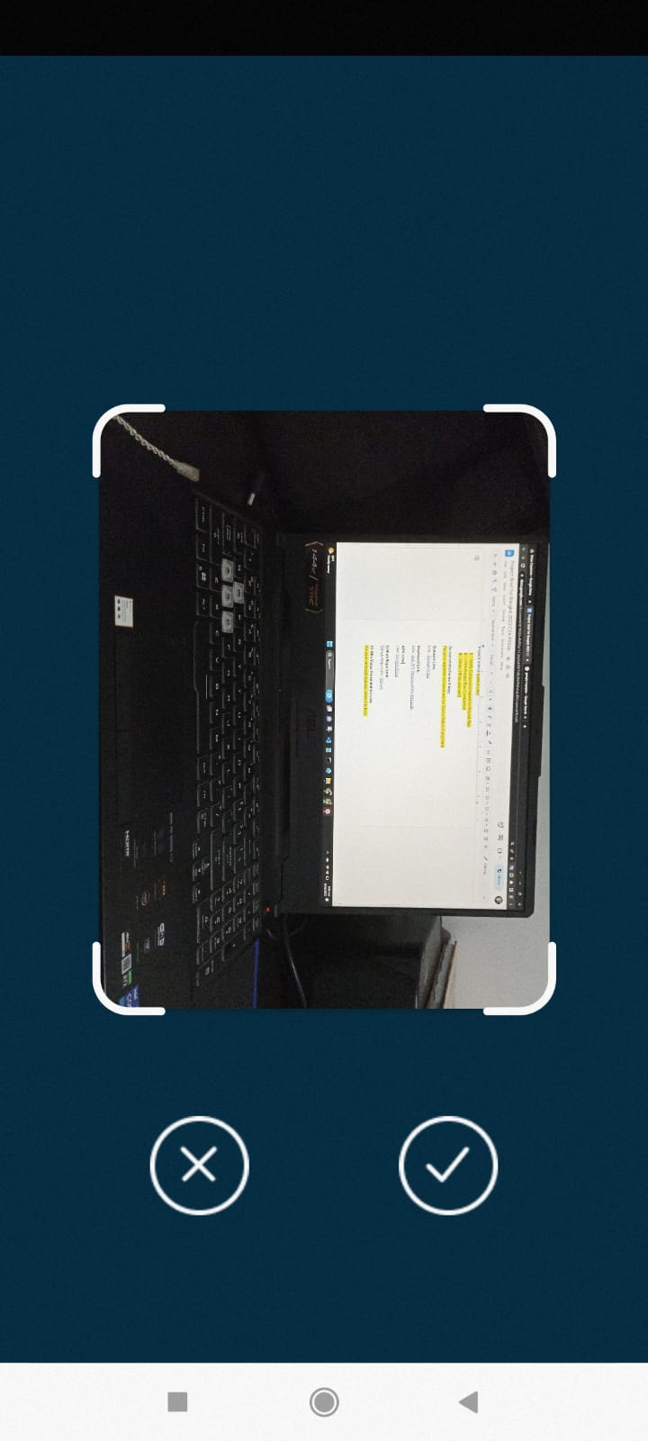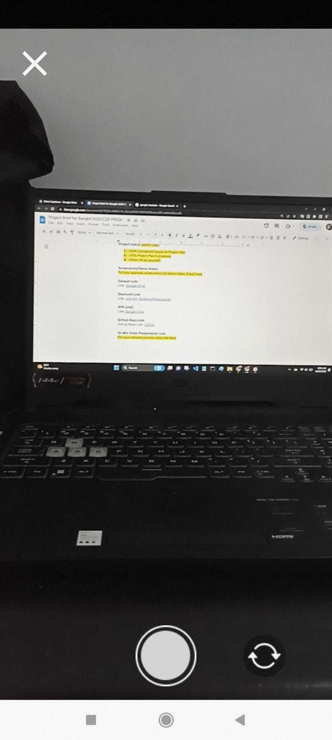

Camera Screen Capture Image Screen

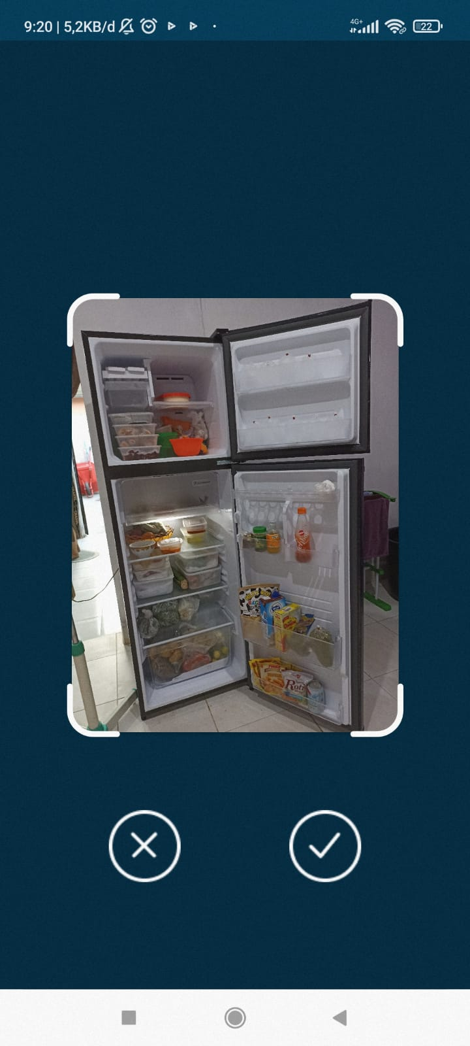

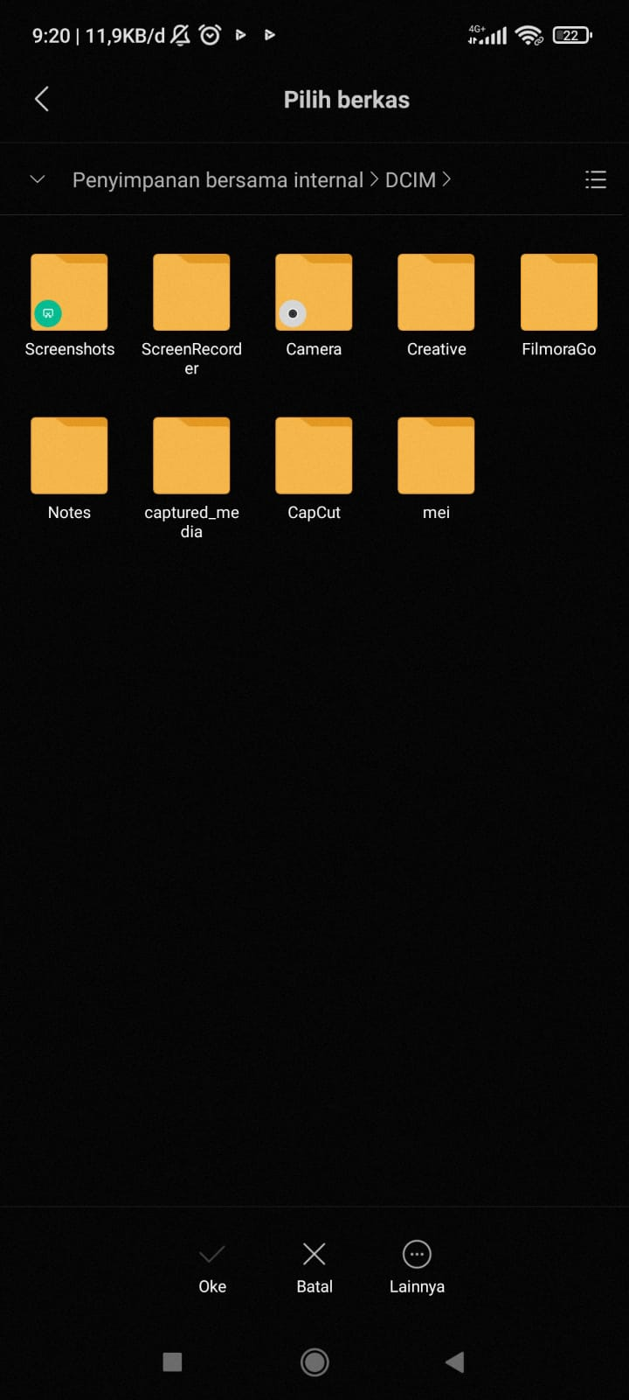

Screen If You Select Upload Capture Image Screen

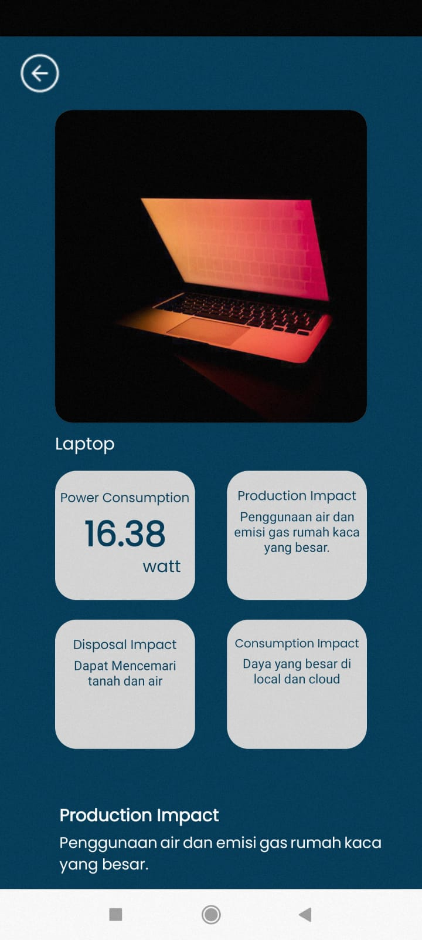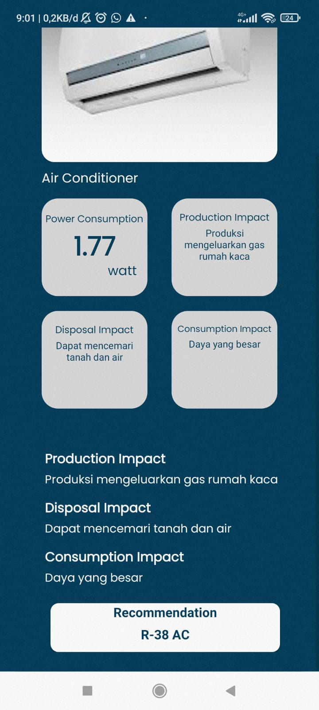

Product Detail Screens Detail Screens With Recommendation

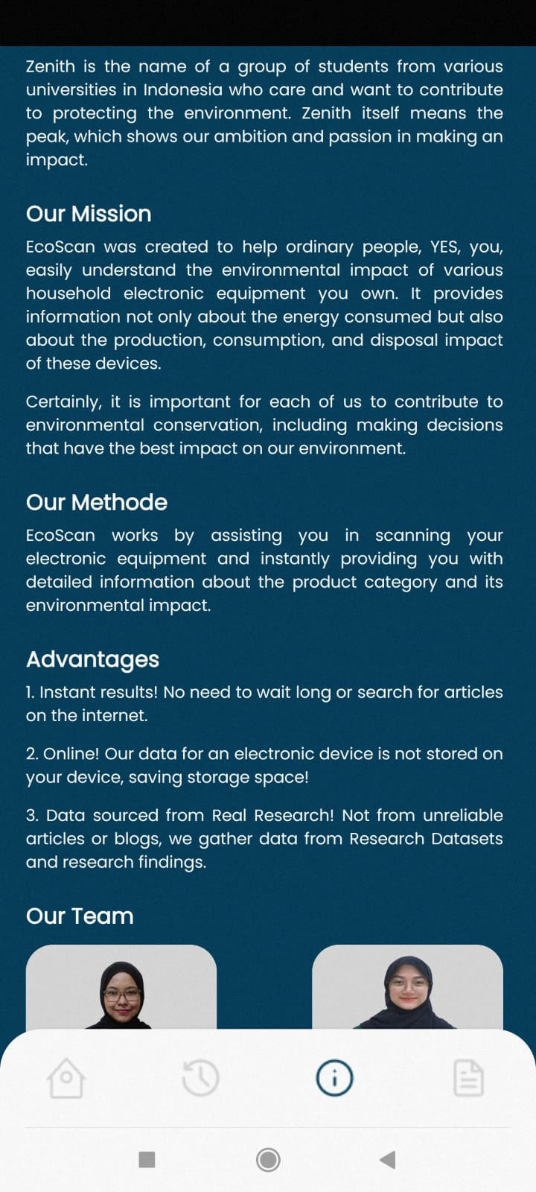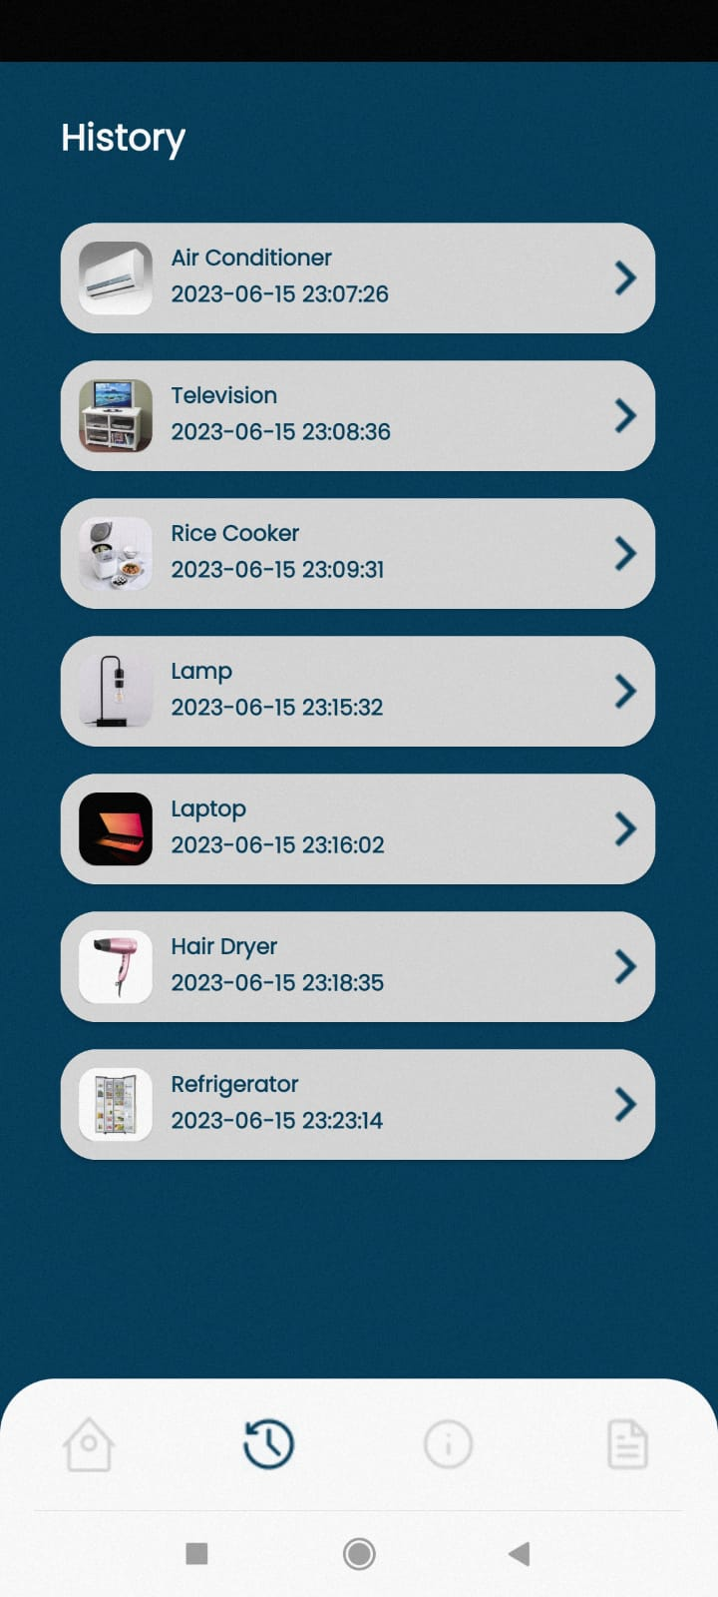

History Screens About Us

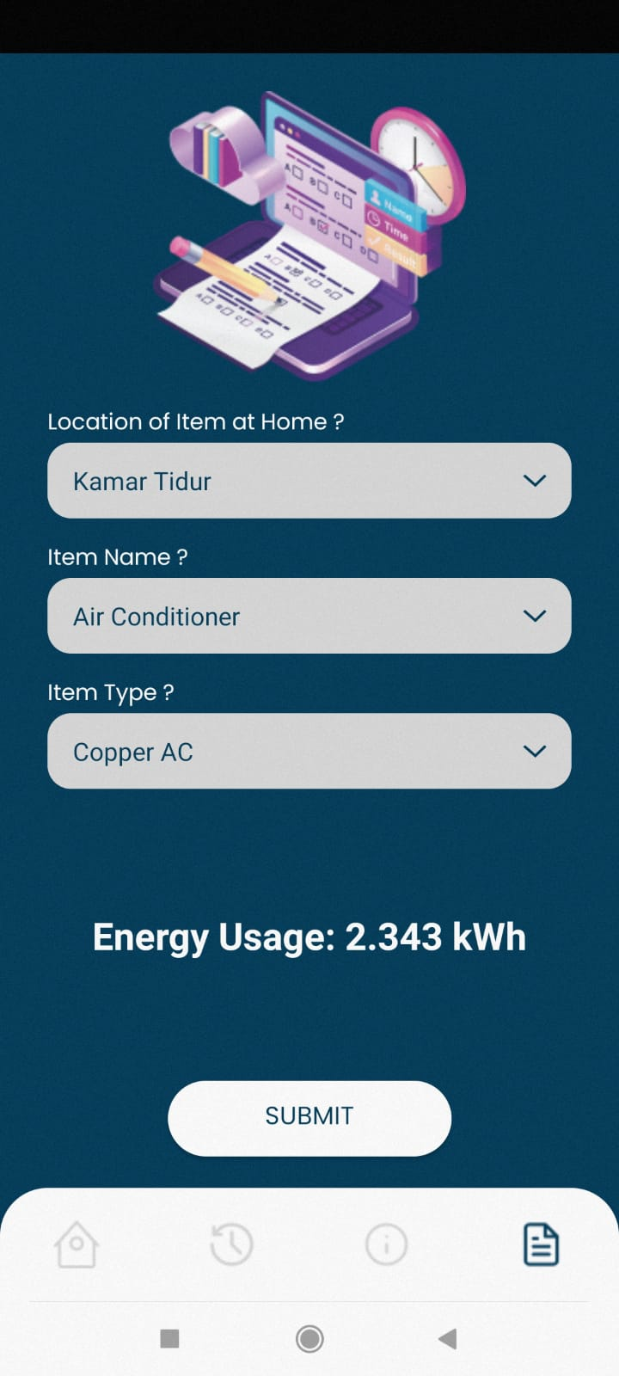

Manual Select According To Your Needs

**Screenshoot Landing Page:**

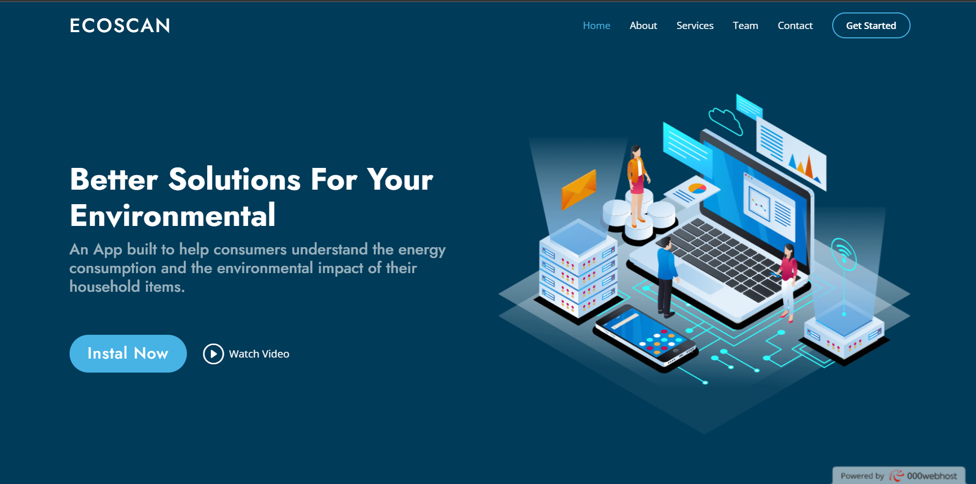

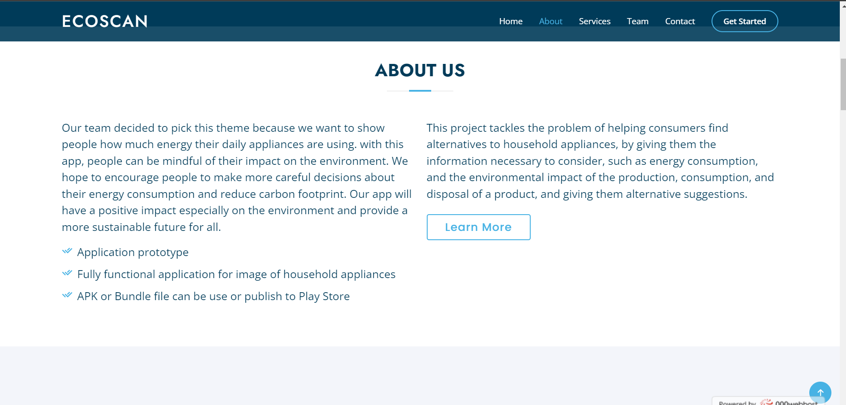

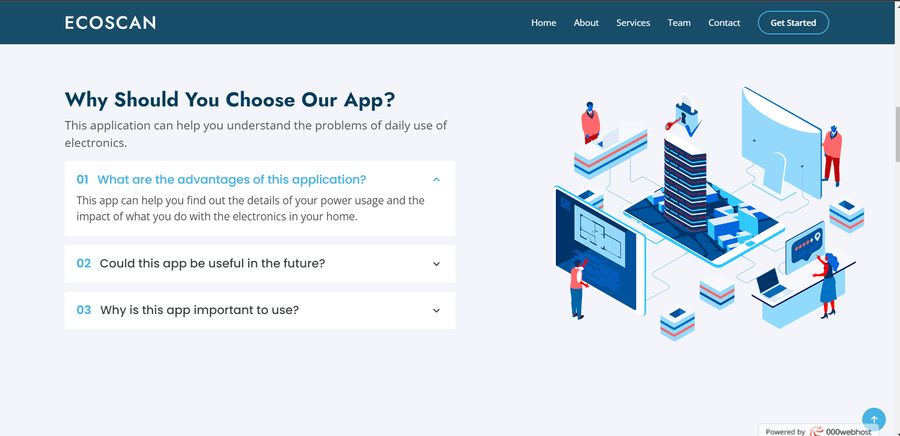

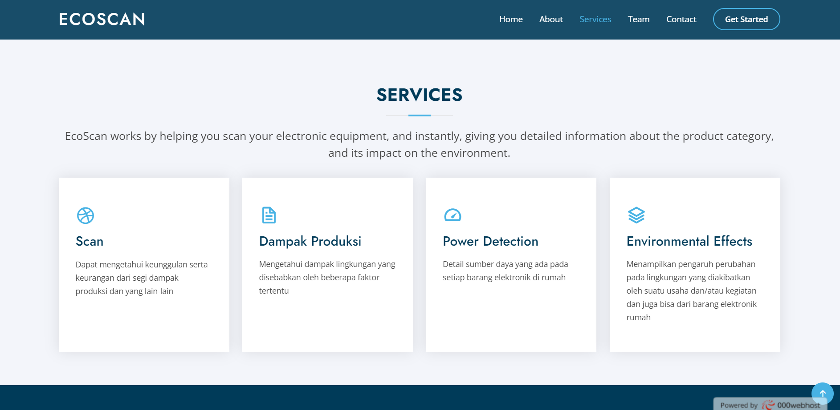

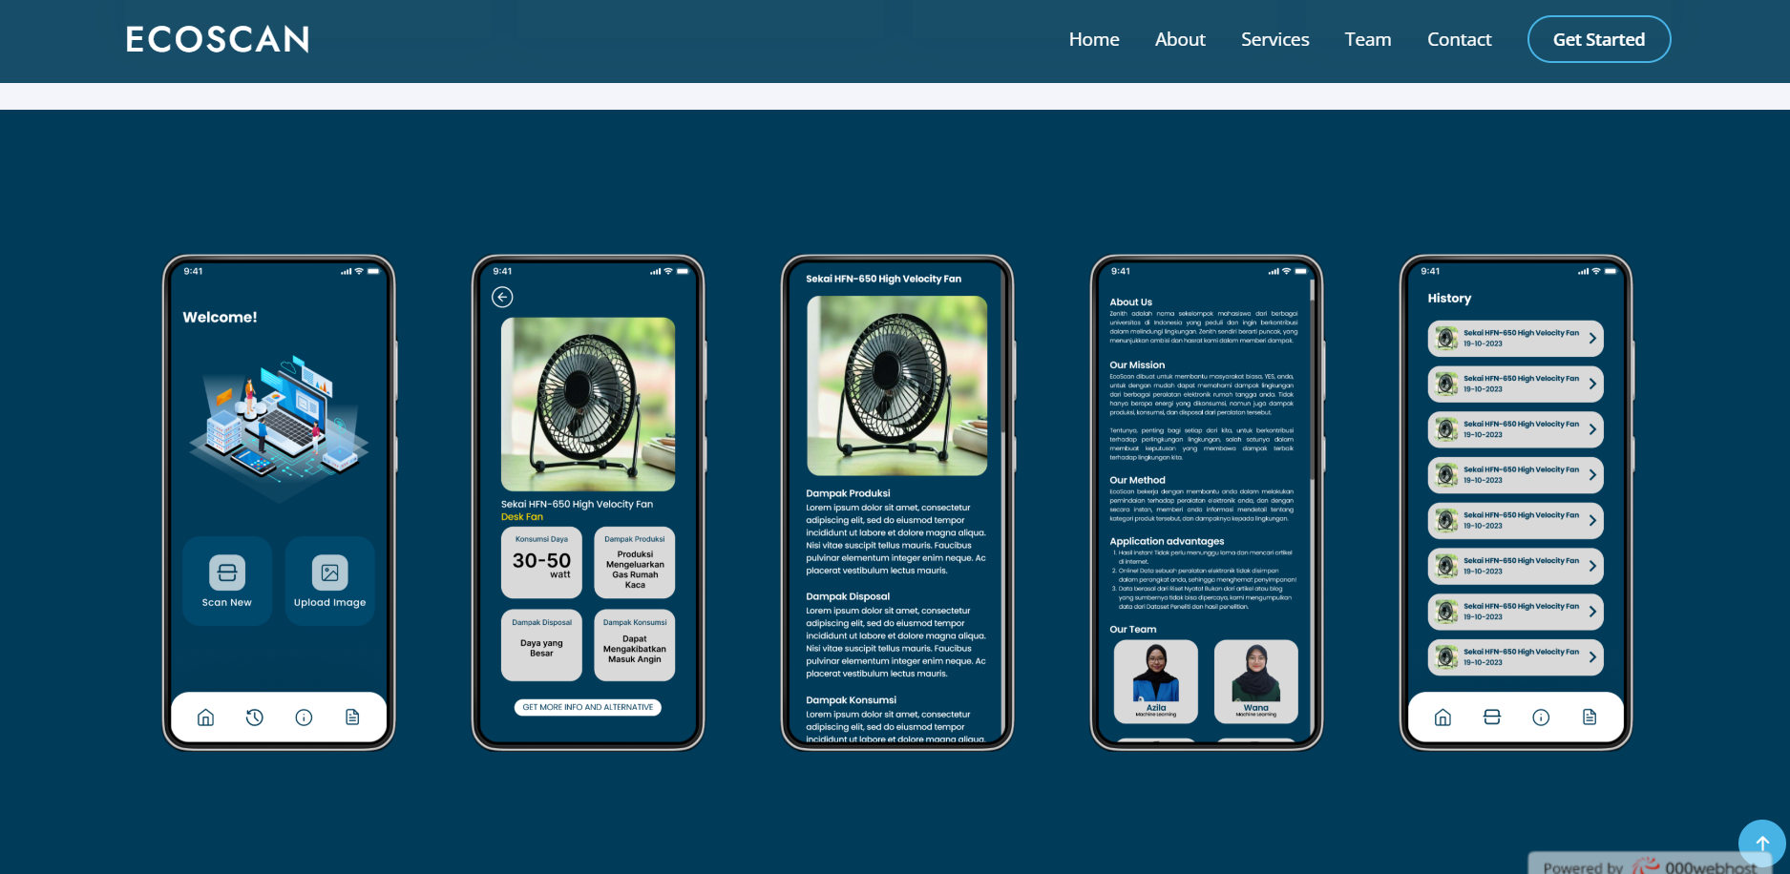

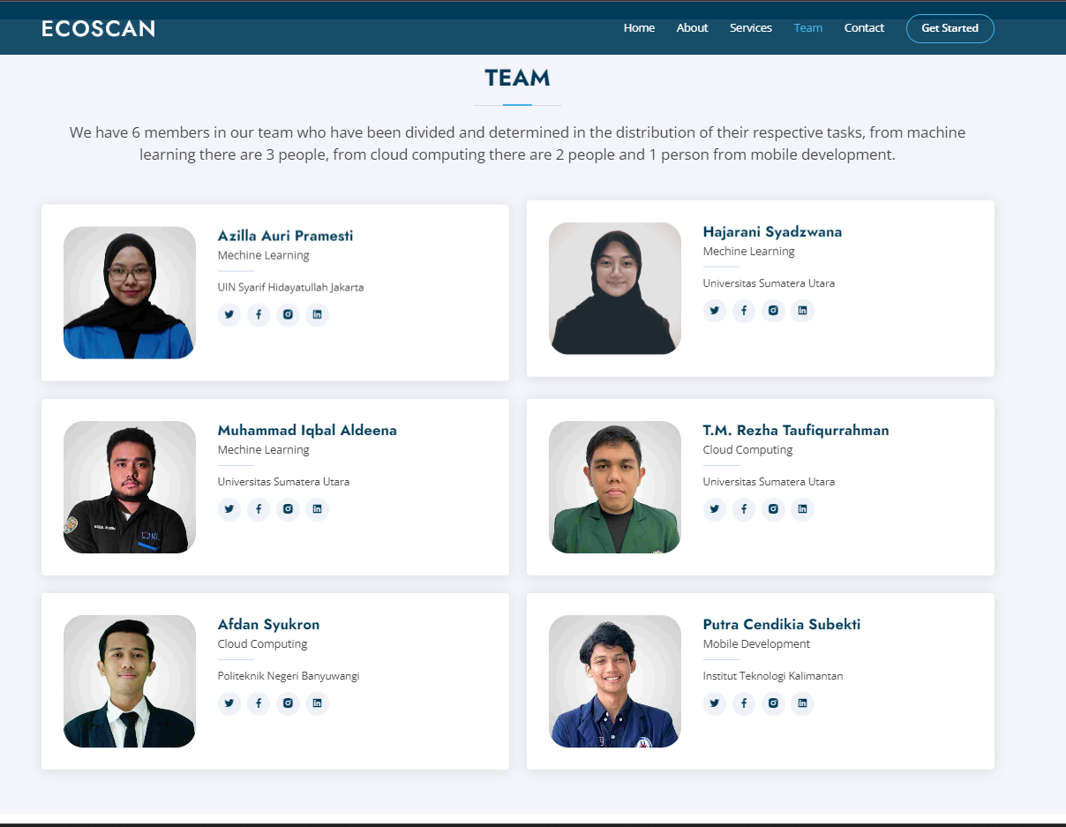

**Demo Video Link:**

Link: You can see it on the drive [Google Drive](https://drive.google.com/file/d/10Ud-Ib9MDlr9SR84gI0atCpfWrd11Mkt/view?usp=sharing) or you can access it from [Youtube](https://youtu.be/v0h4JO6-qG0)

**Dataset Link:**

Link: You can see it on the drive [Google Drive](https://drive.google.com/drive/folders/1Jadk8mU3dPPhifJB0JA1dJF31CPwpNk0?usp=sharing) or you can access it from [Github Dataset](https://github.com/hajaraniwana/Capstone_Team-C23_PR526/tree/ML/Dataset)

**Deployed Link:**

Link: [Link API](http://34.101.91.189:8080), [NotebookModel.ipynb](https://github.com/hajaraniwana/Capstone_Team-C23_PR526/blob/ML/Final%20Model/Final%20Model_DenseNet.ipynb), [APK Link](https://drive.google.com/file/d/1gBF1X9XCueJQHF8WORyFvq4aefiKcBXw/view), [Landing Page](https://ecoscanapps.000webhostapp.com/)

**Github Repo Link:**

Github Repo Link: [Github](https://github.com/hajaraniwana/Capstone_Team-C23_PR526)

**10-Min Video Presentation Link:**

Here is our presentation link:

Link : [Youtube Unlisted 10 Minutes](https://youtu.be/DqPkUHyoVN4)

**Slide Presentation Link(s):**

Link: You can see our presentation slides in the following link[Google Drive](https://drive.google.com/file/d/1Z4qI2NZBUmc4cT39hdf43AMOLDuWIb1H/view?usp=sharing) or [Powerpoint](https://www.canva.com/design/DAFl_H36nbo/2uXf2losgh_fKq2zRE_2iw/edit?utm_content=DAFl_H36nbo&utm_campaign=designshare&utm_medium=link2&utm_source=sharebutton)

**Mentoring Remark(s), if any:**

-